**Z-Rad user guide (v 7.3.0)**

Contents

**1.** **General features:** 1

**2.** **Data sorting:** 1

3. **Resize image and structure set:** 4

**4.** **Radiomics:** 6

**5.** **Radiomics output:** 9

1. **General features:**

Ctrl+s saves settings to a config file

Colors in the text, correspond to colors in the screenshots of the GUI.

1. **Data sorting:**

Z-rad software has two tabs: The first tab is **Images and structures resize**, and in the second tab **radiomic features** are calculated. In order to process your data and calculate radiomics, your data needed to be sorted in a specific way:

**For DICOM files:** Short example of data sorting (Fig 1). In this case, the **main directory** is C:\distributed learning\NSCLC\DOI_3AB\ The folder 1 corresponds to first patient and as you can see it contains image files and a RS file (Unknown). The names of the files within that folder are not important as the software recognizes the files by dicom tags.

The **start and stop** corresponds to your subfolders names (Fig 3), for 1 to 100 the software will try to analyze subfolders from 1 to 100, if a subfolder does not exist it will be ignored so you do not need consecutive numbers for patients naming.

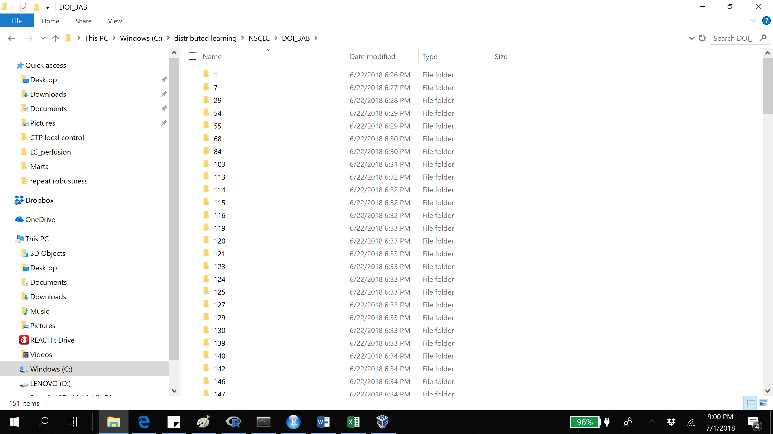

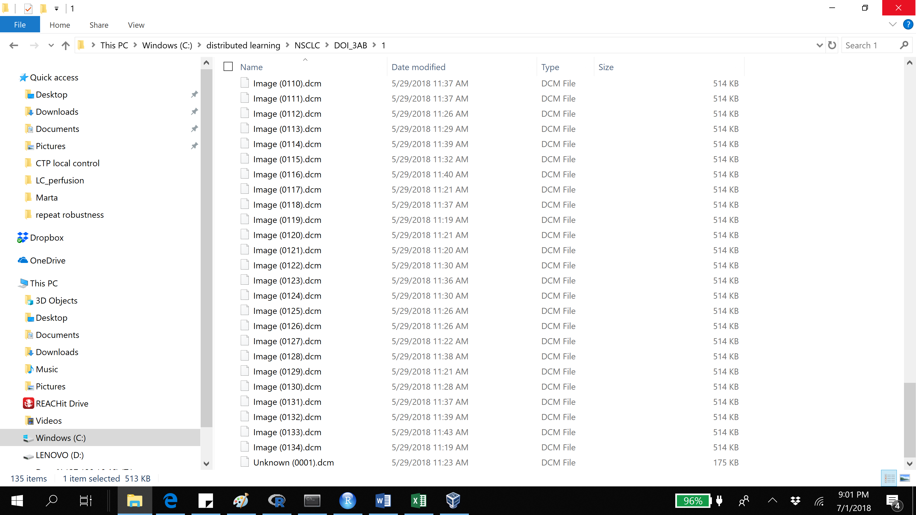

Fig 1. Data sorting example dicom files

**For NIFTI files:** Short example of data sorting (Fig 2). In this case, the **main directory** is C:\radiomics\3_SPHN_IOV\data\2_sorted_for_radiomics\2_resize_NIFTI_2mm\seg1\T1\VOI_combinedThe folder 4 corresponds to first patient and as you can see it contains one image file (T1.nii.gz) and a one mask file (seg.nii.gz). The name of the mask file needs to correspond to the **structure name** (Fig 3). The name of the image file can be arbitrary. If there are more than two file in a directory resize/radiomics will not be performed.

The **start and stop** corresponds to your subfolders names (Fig 3), for 1 to 100 the software will try to analyze subfolders from 1 to 100, if a subfolder does not exist it will be ignored so you do not need consecutive numbers for patients naming.

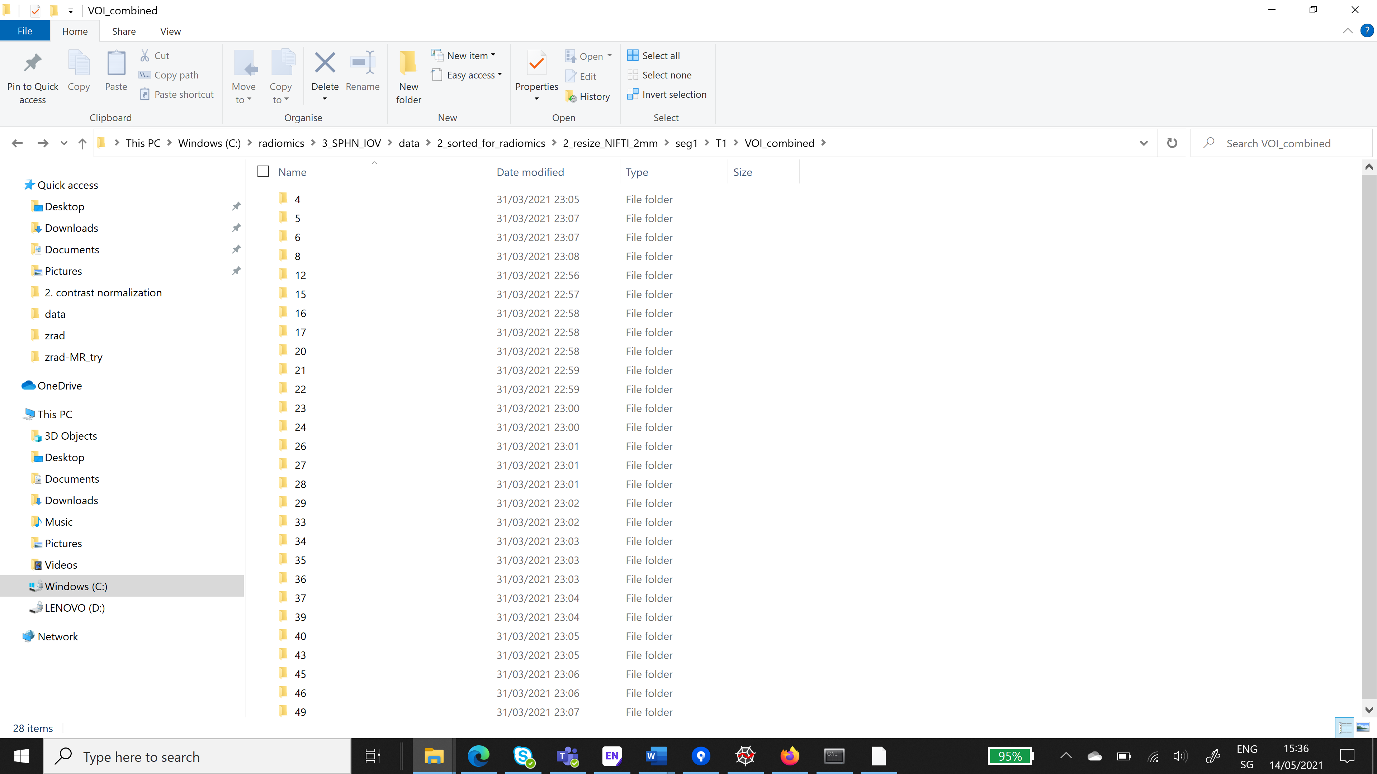

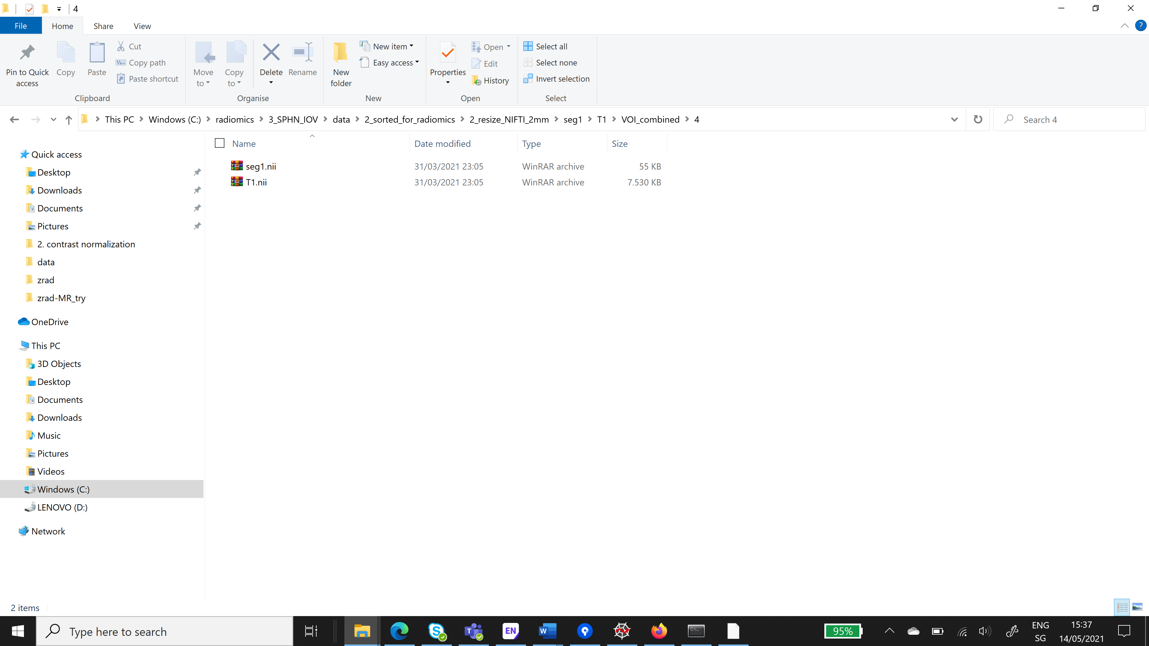

Fig 2. Data sorting example nifti files

1. **Resize image and structure set:**

The module resamples the images and ROI to **user-specified resolution.** It uses linear interpolation to resize the ROIs and **user-specified interpolation algorithm** for the images. For intensity, texture and wavelet features images and ROIs are resized to and resaved as DICOM or NIFTI files (resize texture tick). The resize can be done in 2D or in 3D. For shape features the ROIs are resized to 1mm resolution (for user-specified resolution >1mm, otherwise to 0.1mm – useful for analyzing preclinical data) and all the points inside the contour are saved as text files, separate file for each slice (resize shape tick). The shape resize is only available for the DICOM files. The files are saved in the **main directory** specified by the user. Files for all patients should be saved in **one main directory.** Data for single patient should be **stored in subfolder** (both images and RS file in the same folder). Subfolders need to be named using numbers only. You have to specify if you plan to analyze **DICOM or NIFTI** files.

For DICOM: Only the **ROIs specified by the user** are resized. The ROI names should be separated with ‘,’. Check button – reads data for all the patients and checks if specified ROIs are present. Saves results in an excel file in **main directory**.

For NIFTI: The name of the mask file needs to correspond to the **structure name.** It is possible to resize only one mask at the time. Specify the intensity level used to label your mask in the **labels**. You can input more than one label (separated with ‘,’). It will merge those contours. The resampled mask has label 1.

Resize button – starts images and ROIs resizing. During resizing program can go into non-responding mode. It is normal as long as no error appears in the console window.

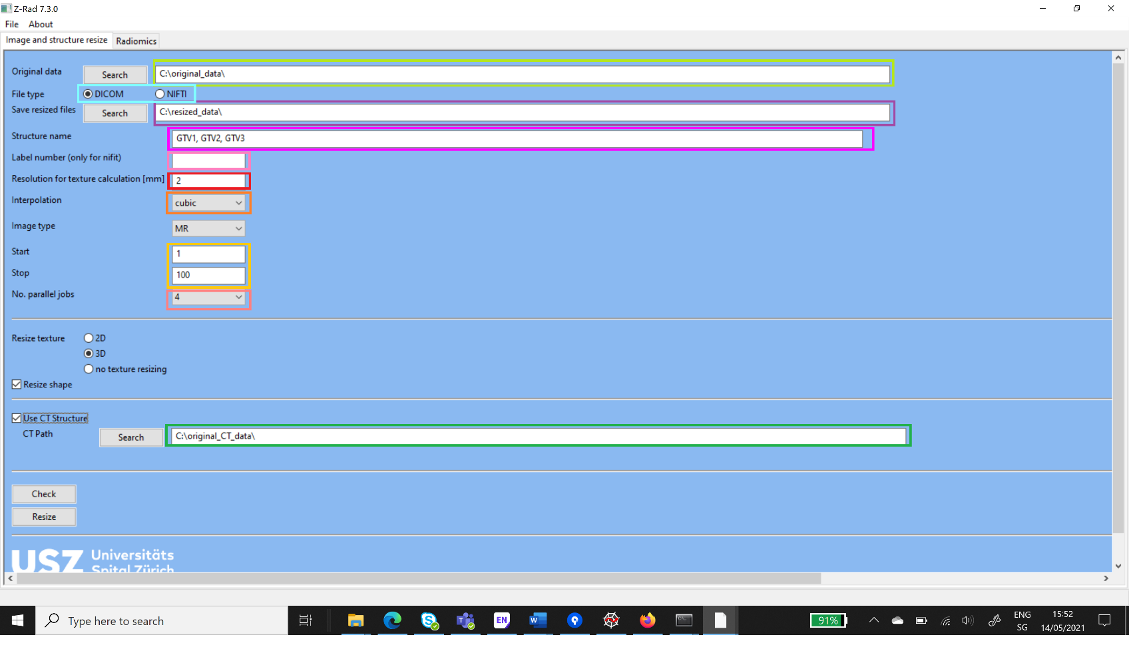

Fig 4. Image and ROI resize example for DICOM files

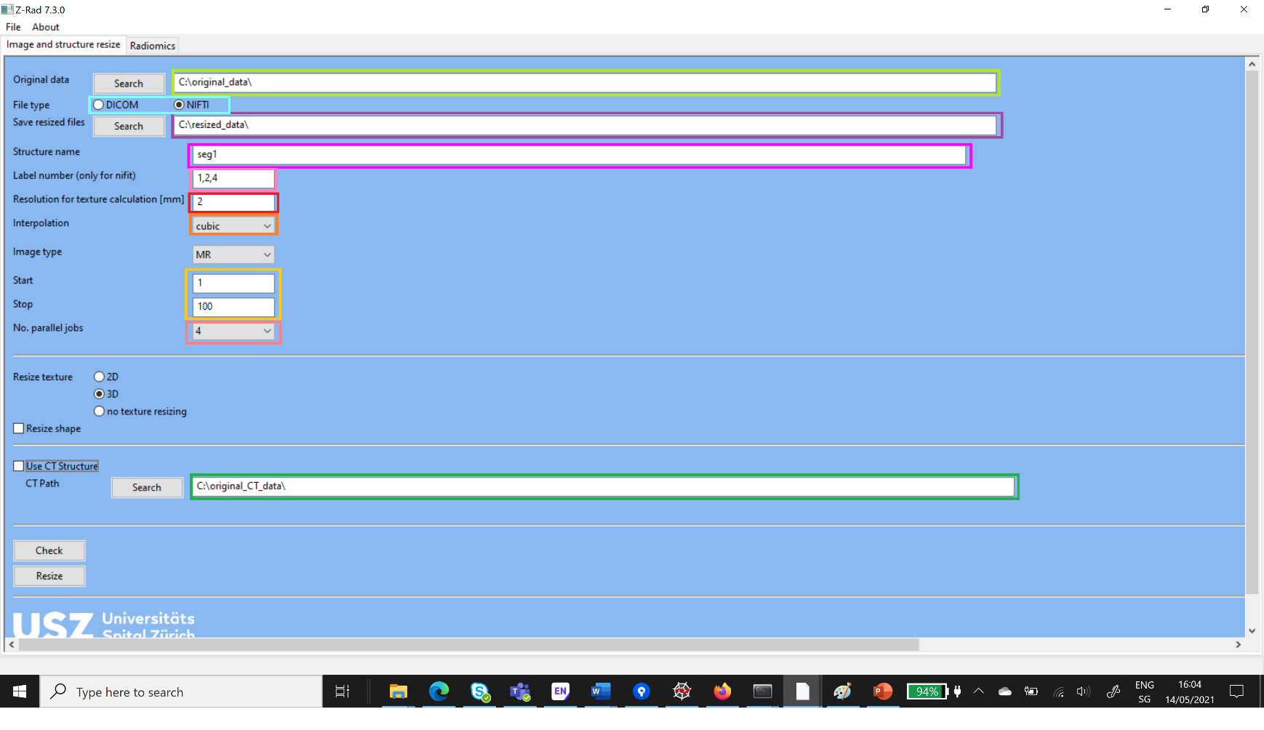

Fig 5. Image and ROI resize example for NIFTI files

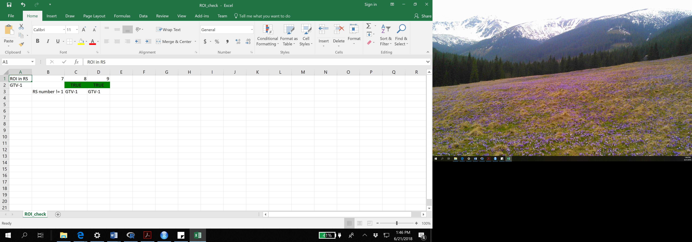

Fig 6. Output in the ROI check file. Patients 8 and 9 have RS file containing GTV-1. For patient 7 more than one RS file or no RS file is present in the folder.

1. **Radiomics:**

**Load**: main directory with resized data.

**File type**: select NIFTI or DICOM files

**Start and stop**: range of patients subfolder to be analyzed

**Save results in**: directory where radiomics results are saved. Below give the name to the file with parameters ie radiomic_pat_1-100

**Select ROI**

* DICOM**: Structure name** - name of the region of interest to be analyzed. If the ROI names are not standardized throughout the dataset the possible names can be separated with comma.
* NIFTI: The name of the mask file needs to correspond to the **structure name.** It is possible to calculate radiomics only for one mask at the time. Specify the intensity level used to label your mask in the **labels** (in the case you used the resize functionality of Z-Rad your label is always 1). You can input more than one label (separated with ‘,’). It will merge those contours.

**Discretization**: Bins No (fixed number of bins, for example 32), Bin size (fixed bin size, for example 5 HU or 0.5 SUV).

**Wavelet transform**: calculate wavelet features yes/no

**Shape**: calculate shape features yes/no. **Give a name of the ROI for which shape should be analyzed**. Can be different than Structure name, for example when artifacts are present.

**MR normalization:** select type of normalization

* **Linear:** specify names of two ROIs (normal structures) used for linear rescaling of the intensities. Available only for DICOMs
$${intensity}_{normalized}= {intensity}_{original}\frac{500}{{intensity}_{ROI2}-{intensity}_{ROI1}}+800- \frac{500{ intensity}_{ROI2}}{{intensity}_{ROI2}-{intensity}_{ROI1}}$$

* **Z-score** (based on ROI or brain): select the right ROI for normalization in the ROI for advanced normalization. Available for both DICOM and NIFTI.
$${intensity}_{normalized}=\frac{{intensity}_{original}-mean}{standard deviation}$$

* **Histogram matching** (based on ROI, brain or brain-ROI for dicom and based on ROI for nifti): select the right ROI for normalization in the ROI for advanced normalization. Brain is automatically segmented with hb-bet. In the case you have already the brain masks saved in nifti format you can input the **main directory** (the main directory should contain the masks names patientNumber_mask.nii ie 1_mask.nii). You need to specify the **template array** to match the histogram to, it has to be a numpy array.

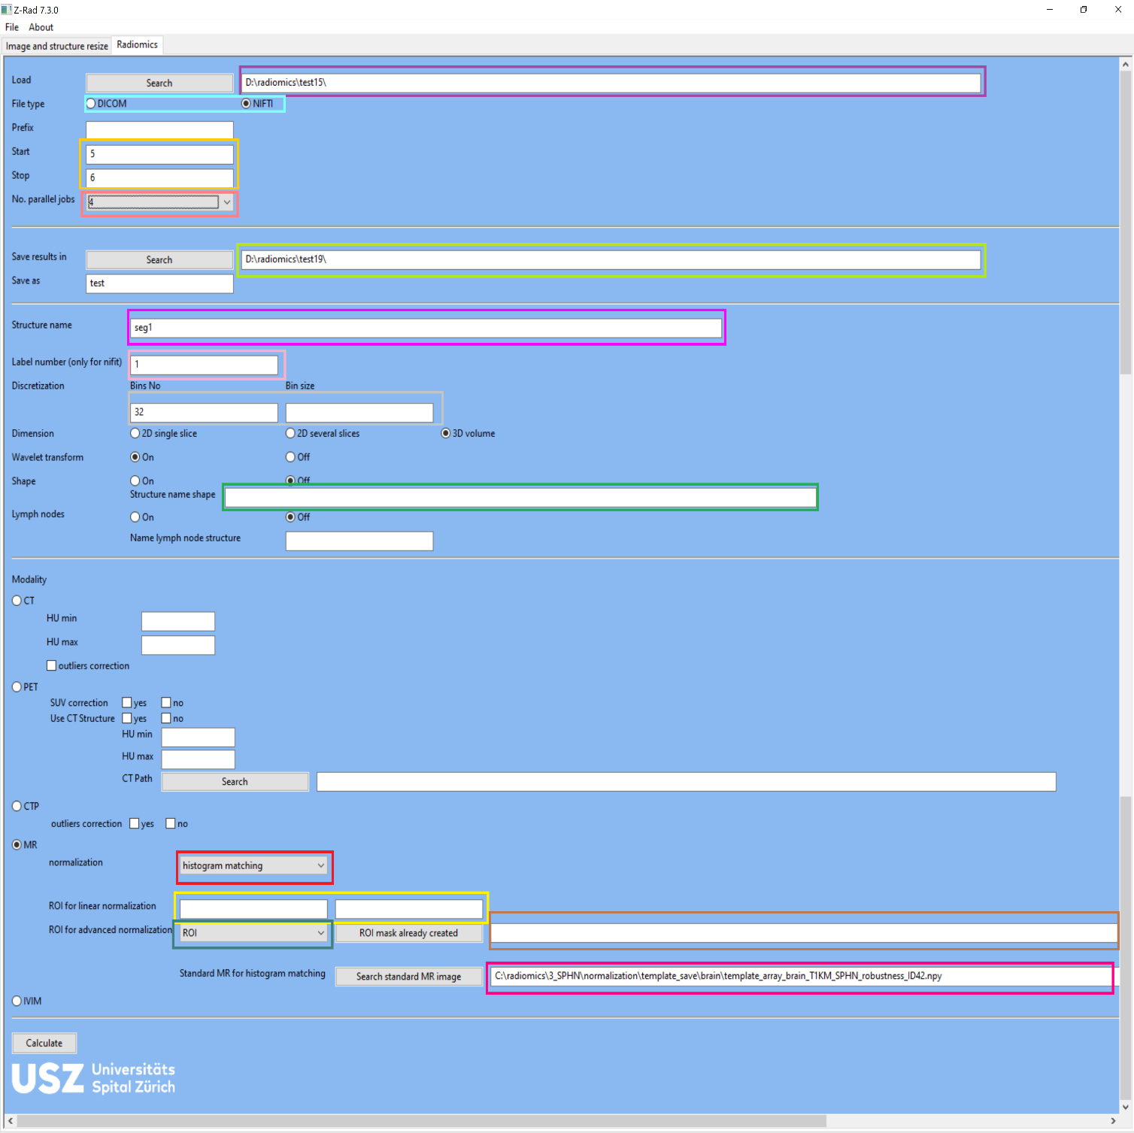

Fig 7. Radiomics calculation tab

1. **Radiomics output:**

Z-Rad software will output the results inside the **folder you have selected for your result.**

1. For each patient, one folder is created that stores the results of the ROI contours once in grey-level scale and once color-scale.
2. **Fractals**: For each patients, there is a plot of the fractal dimension calculation.
3. **Histogram**: Each patient has eight histogram plots, labeled with _0 for the histogram based on the original intensity values, then _1 to _8 for the corresponding intensity histogram on wavelet-filtered images.
4. **Wavelet**: During the calculation of radiomic features, wavelet filtered images are created and stored temporarily in this folder. All the subfolder are empty.
5. **Texture and shape results**: Radiomics features are stored in the shape and texture text files.
6. **Excel File**: stores the combined results of texture and shape results, it saves also settings of the radiomics calculation
7. **For MR normalization**:
   * brain_mask_png: png files with autosegmented brain
   * brain_mask: nifti files with autosegmented brain mask and image
   * 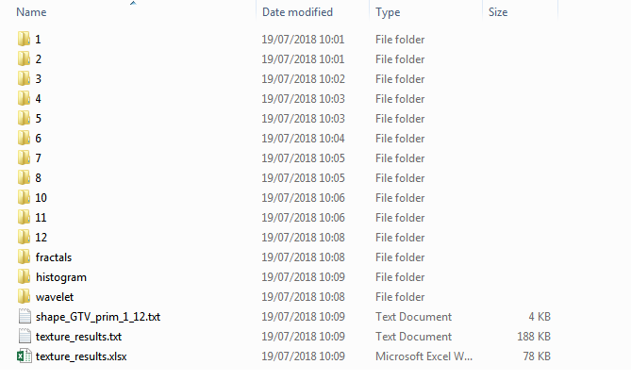brain_mask_hist: png and nifti files of the image after histogram matching

Fig 8. Z-Rad Output